**Report on IIP course**

**School name:** SCOPE

**Faculty name (ERP No): Dr. B. Ajitha (51687)**

**Academic Year:** Winter semester-2021

**Title of the project:** Segregation Made Easy

**Number of students involved in the group:** 8

**Student name along with the Registration numbers involved in the project**

1. Anas Ahmad Siddiqui (20BPS1094)

2. Anosh Damania (20BAI1152)

3. Gauthama (20BAI1262)

4. Meher Shrishti Nigam (20BRS1193)

5. Shreya Ramarao (20BRS1200)

6. Sree Lakshmi (20BEC1195)

7. Vagadeeshwar (20BPS1098)

8. Vanisha (20BEC1195)

**Brief description of the project:**

This project aims to develop a website that helps the user to segregate their waste into recyclable or non-recyclable. Deciding what category of waste a particular item falls into is difficult and our aim is to make this task easier. The user types in the name of the waste that they want to segregate and the website replies with “Organic or Biodegradable waste” “Dry waste” and “Domestic Hazardous waste”. The website also aims to educate users about the proper way to dispose of various items, helping the users reduce the waste generated.

**Outcome of the project**

We made a website that helps for the purpose of distinguishing types of waste materials. The necessity of distinguishing wastes has come to an alarming state, hence one has to be aware of how to distinguish between waste materials. This project serves for purpose of distinguishing between waste materials. Our website helps the customer by letting them know what type of waste is the waste material they've searched for. Our website stands out beside the other websites as its customer friendly and is quite simple to use.

The webpage front-end was developed using HTML and CSS. It is a 4 page website including the home, about, contact and categorize page.

* 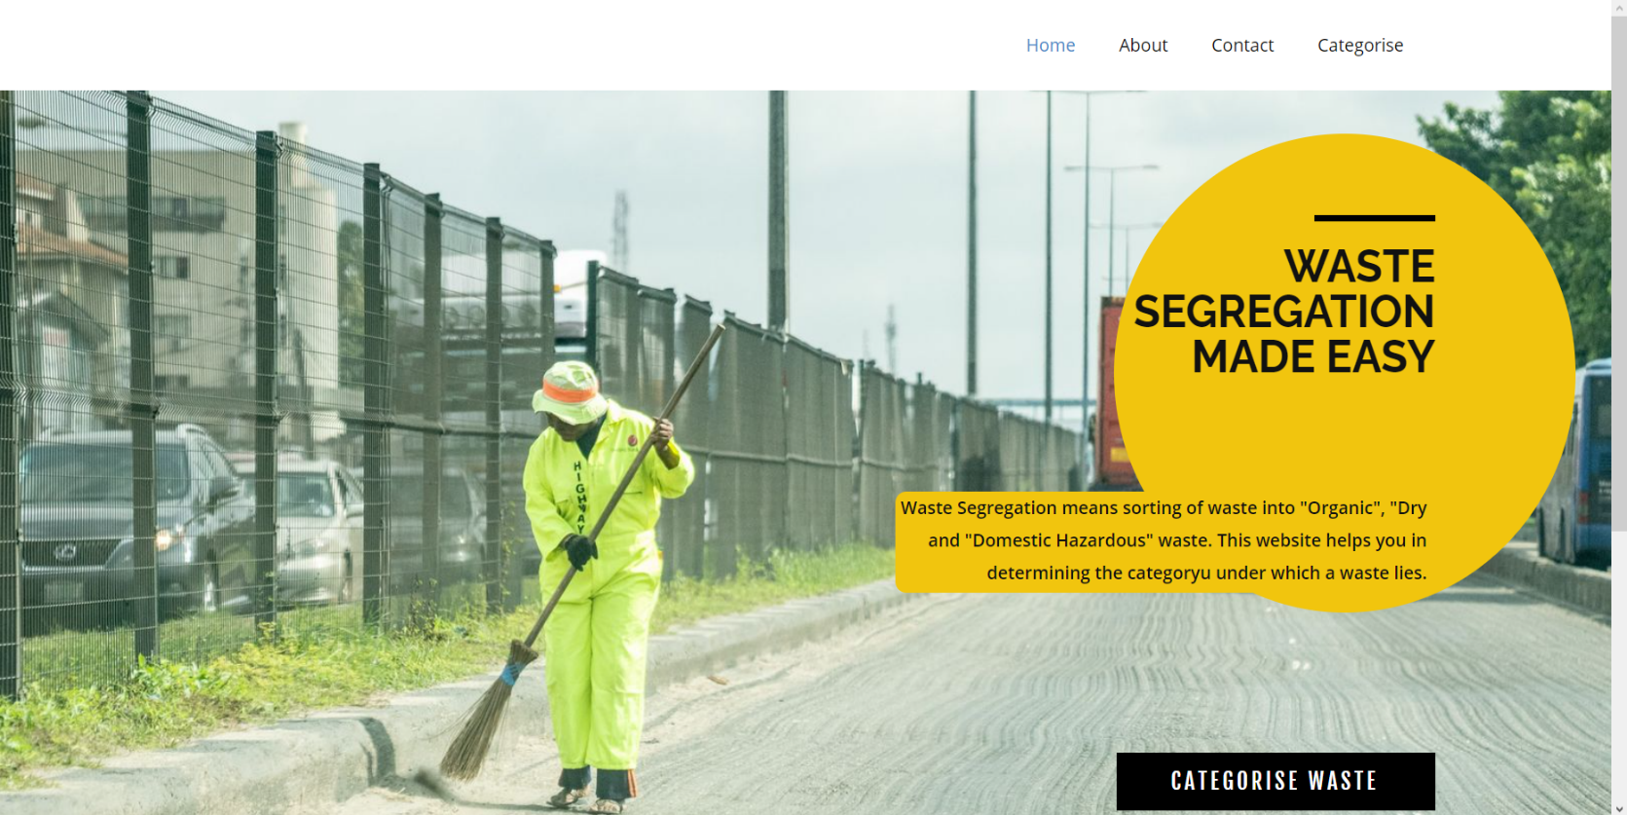Home page gives a little introduction about our project.
* 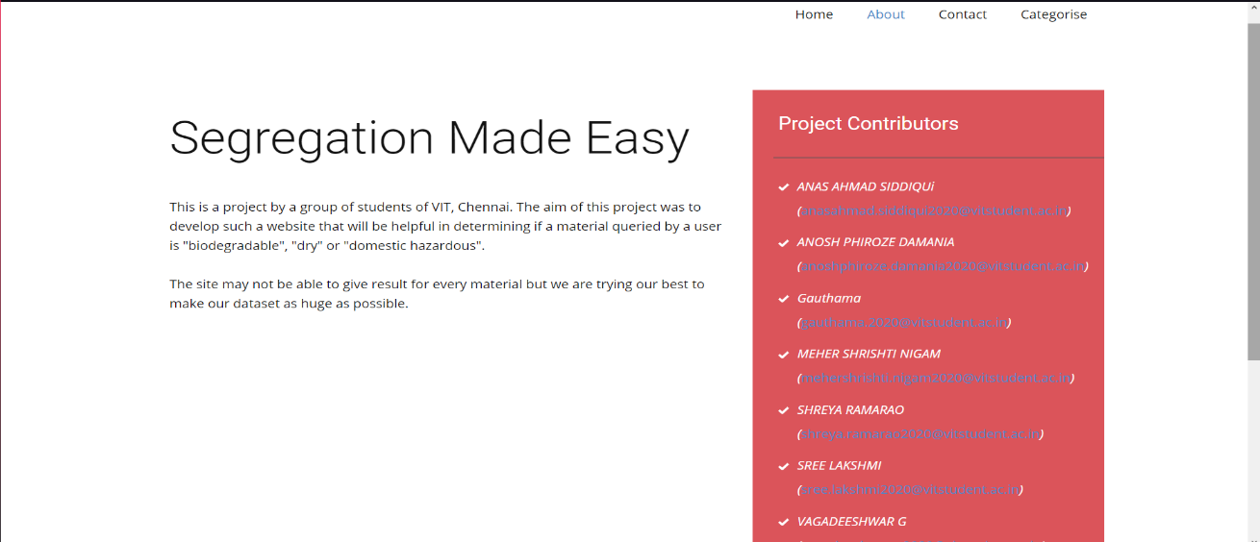The About page contains all the group members information and description of the website and its working.
* 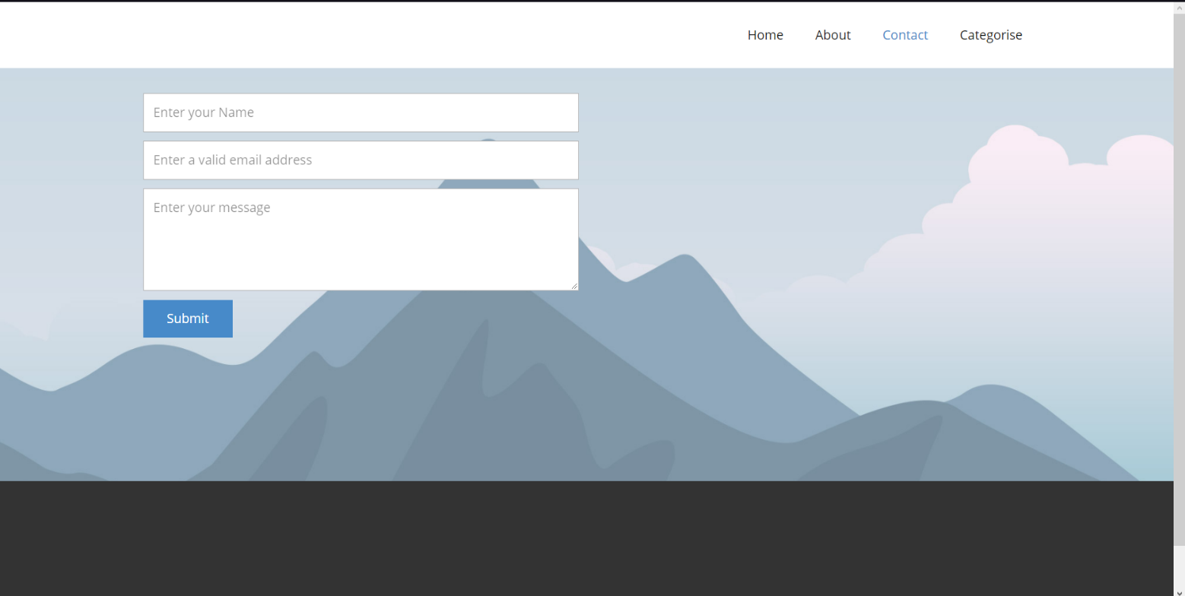The contact page can be used to report a bug.
* The category page is the main working page of our project. This is where the user will enter the name of waste material and the website will return the category.

Working of the Category Page: The webpage takes the input from the user and sends the string to the JavaScript script named app.js which checks if the waste name is already in the dataset sample.csv and if it finds the entry it returns the category corresponding to it.

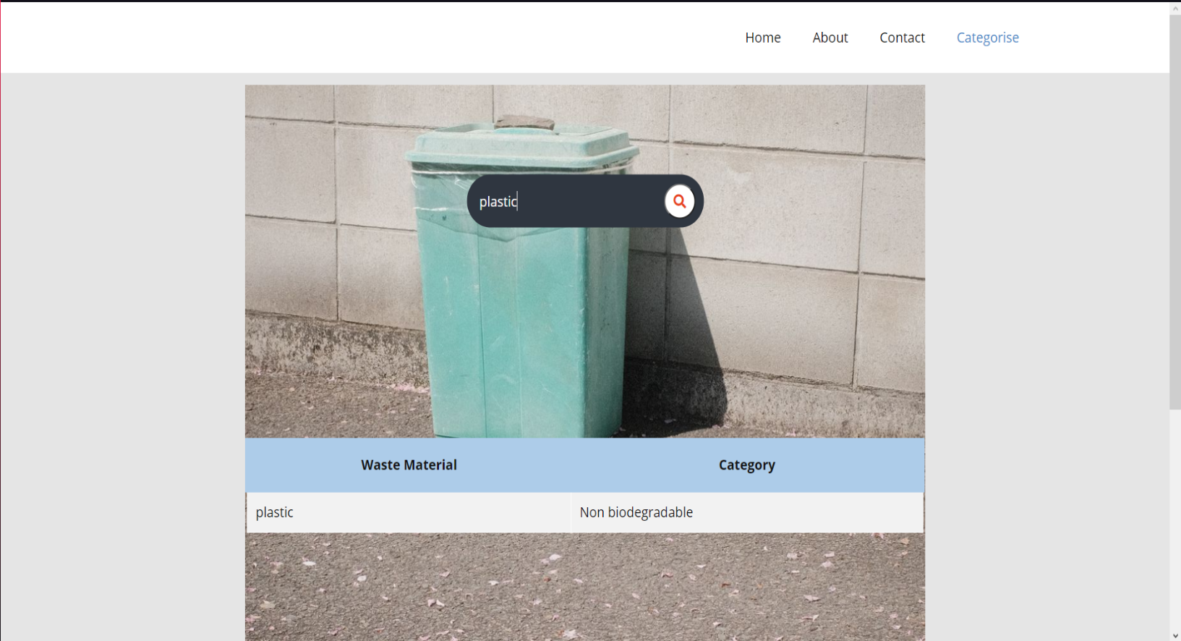

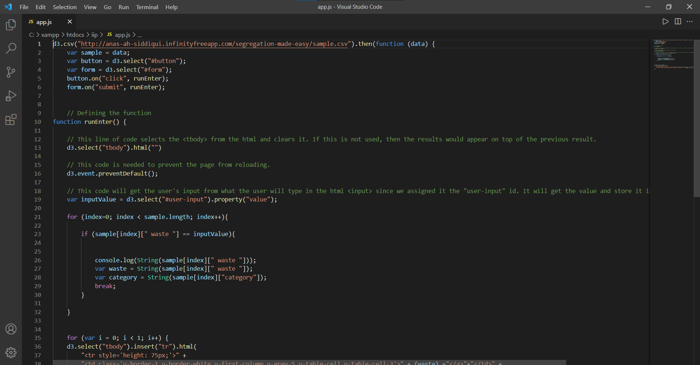**JavaScript sample:**

**Dataset Sample:**

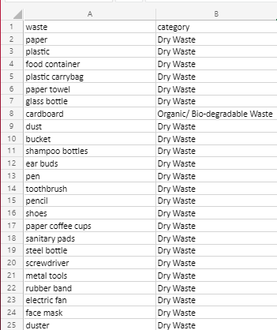

**Individual Contribution:**

I, Anas Ahmad Siddiqui (20BPS1094) made the entire front-end part of the website and did the whole coding part for the same. I also connected the website with the dataset and made sure that the website returns an output from the dataset.

**Signature of the Faculty member**